

Assessment Cover Page
Student Full Name
Eduardo Schneider Flach
Student Number

2026365
Module Title
Stats for Data Analytics – CA1
Project Title
Stats for Data Analytics - Obesity
Lecturer/Supervisor
Taufique Ahmed
Assessment Due Date
01/11/2026
Date of Submission
01/11/2026
GitHub Acess:

Use of AI Tools

I have not used any AI tools or technologies in the preparation of this assessment.
Declaration
By submitting this assessment, I confirm that I have read the CCT policy on academic misconduct and understand the implications of submitting work that is not my own or does not appropriately reference material taken from a third party or other source.
I declare it to be my own work and that all material from third parties has been appropriately referenced.
I further confirm that this work has not previously been submitted for assessment by myself or someone else in CCT College Dublin or any other higher education institution.

Sumary
Introduction 1
Task One 1
Aim and Objectives 1
References 2

Introduction
The chosen data set is available at UCI repository named “Estimation of Obesity Levels Based On Eating Habits and Physical Condition”. It contains 16 features, including categorical and numerical values. It contains 2111 instances but not all off them will be used in this assignment.
In summary, the aim of the data is to collect information based on the habits of the people relating with the obesity level. There are 12 categories and the people could choose a range of categorical options. The numerical data is related with the age, Weight and Height.
According to the author of the data, about 23% of the data were collected directly from the users and the rest of the data was generated synthetically using the Weka tool and the SMOTE filter (colocar referência). As the main objective of this assignment is to understand the use of the Jupyter notebook and its facilities, the present project will work just with the 23% of the data.

Task One – Summarize the data set
The first step was to separate a new data named “df_raw” excluding the data generating by SMOTE as below. Therefore, this project will work with 498 lines:
df_raw = df.iloc[:498].copy()
In the next step, it was used some function to understand the data, such as head and tail function, shape function that consolidate the usage of just the directly collected data: (498, 17). For some features I used the unique function to check how many possibilities were in each feature.
Using the function info, some extra information regarding the data was provided. First, there are no missing values in the dataset. It was also used the function isnull().sum() to confirm this. Secondly, for the categorical features, the program understands categorical features as numerical ones. The explanation is because the possible answers in the survey, for example:
The column “family_history_with_overweight” there are to possible answers, “yes” or “no”. However, in the question “How much water do you drink daily?” there are 3 different possible answers: “Less than a liter”, “Between 1 and 2 L” and “More than 2 L”. These 3 different kinds of possibilities were encoded as “1”, “2” and “3”. The author didn’t explain why the data was kept like that.
In the next step I explored some information for the continuous value using the describe function as below:
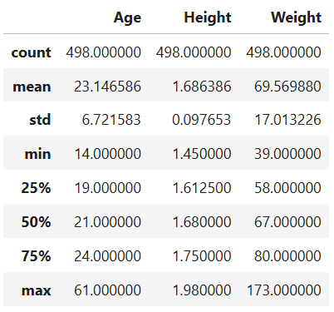
In the next step, it was calculated the mean = 69.57, medium = 67 and mode = 60 for the “Weight” feature.
After that it was plotted a graph showing the 498 data. Just seeing the graph, it looks like a bell shape but skewed to the left. Another perception is that the data goes up to 160kg, probably containing outliers.

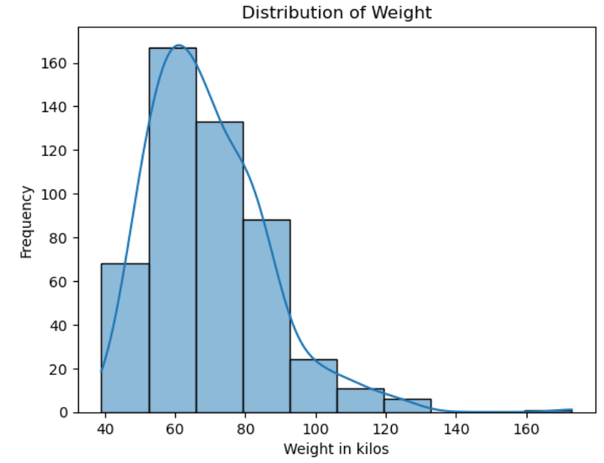
Using the formula Min and Max, I could check the range of the Weight feature. The minimum value was 39kg and the maximum was 173kg, giving a range of 134kg.
The variance of the data is 289.45 which indicates a great dispersion. And the standard deviation is 17.01 which indicates the range of the data related with the mean.
Then, using the IQR formula it was possible to check if there are some outliers in the data. Q1 = 58 and Q3=80. The IQR value resulted in 41.95. Plotting the data in a graph we can see that there are some outliers in the data, highlighted in yellow.
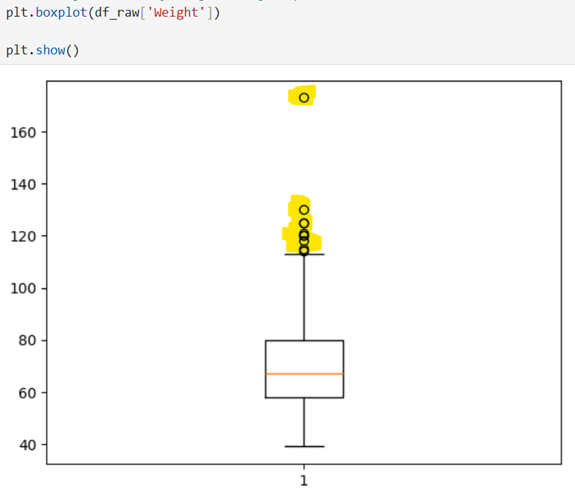
The kurtosis formula could indicate a presence of outliers in the data set. The number resulted was 3.00448. Numbers higher than 3.00 indicates that the dataset has heavy tails or outliers. This means that extreme values are more frequent than expected in a normal distribution. The number is almost exactly in the middle of the turning point number.
Other feature that is possible to use is the Skewness number. Positive skewness number indicates that the tail on the right side of the distribution is longer or fatter than the left side. This often suggests that there are a few high-value outliers. As an example, the number 174kg presented in the dataset. The current amount of skewness for the Weight is 1.1935.
Bellow a graph showing the data for Weight, but in the y axis was plotted the density of the data instead of the total number.
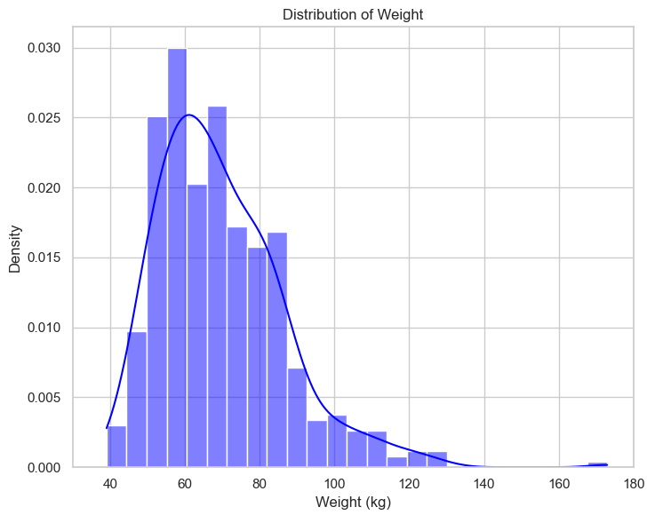

Binomial and Poison Distribution

Normal Distribution
The feature that I will analyse is the Height. Usually, this feature behaves like a normal distribution in real live. The objective is to check if for the 498 amount of data it is the same behaviour.
First, I plotted a graph to check the shape. The result was similar with a bell shape as bellow.
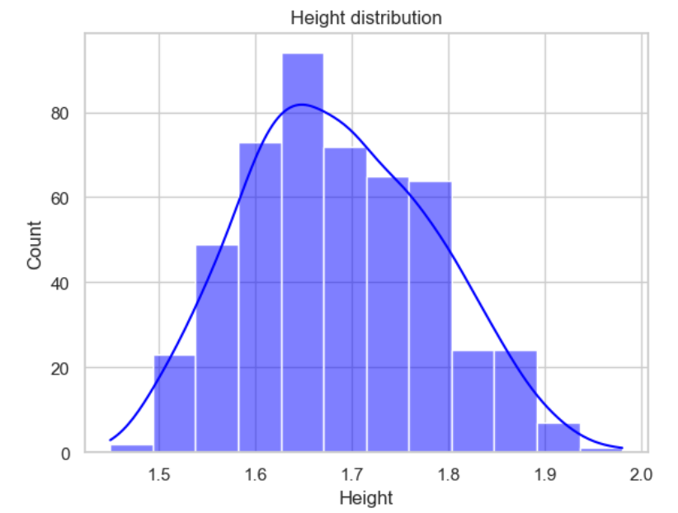
Then, with the mean and standard deviation (std) I used the 68-95-99.7 empirical rule, which states that 68% of the data is within the first std, 95% with the 2nd std and 99,7% within the 3rd std. The result shows that 67,27% of the data is within the 1st std, 97,39% are within the 2nd std and 99,8% are within the 3rd std. It is clear that this data is a normal distribution
With the function z-score it is possible to check for all the data how far the current value is from the mean. For example, the first value is -0.680491 far from the mean (1.68cm), which means that the value is bellow the mean but within the 1st std.
I plotted the function head to double check the first value of the data. The number is 1,62 which means the z-score is correct.
Also, I plotted the Q-Q plot. It compares observed quantiles with quantiles expected under a normal distribution. If the data are approximately normal, most points should lie reasonably close to the reference line. The results are showed below.
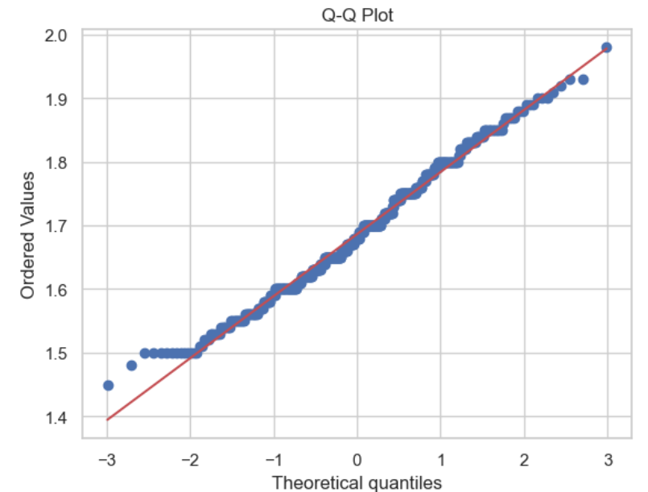

References

